SATURDAY 10th JUNE – DAY ONE STAGE NOTES

EVENT START LOCATION: LLANGORSE LAKE, BRECON, POWYS. LD3 7TR

All teams must arrive at Llangorse Lake for a transfer to the start line between 07:30 and 08:30.

Staggered team transfers from Llangorse Lake to Talybont-on-Usk will take place between 08:00-09:00. These times will be revealed the evening before.

Kit checks and team briefings will take place at Talybont-on-Usk from 08:20 with the first wave of the race beginning at 09:00.

All teams must register a maximum of 7 participating team members for the day upon arrival.

ALL STAGES ARE ELECTRONICALLY TIMED. PLEASE WEAR YOUR TIMING TAG AT ALL TIMES AND PASS OVER THE TIMING POINT AT THE START AND END OF EACH STAGE.

IN CASE OF EMERGENCIES/NEED FOR ASSISTANCE CALL
EVENT CONTROL: 07906888599

Stage 1 | Mountain Bike Ride – Talybont Forest
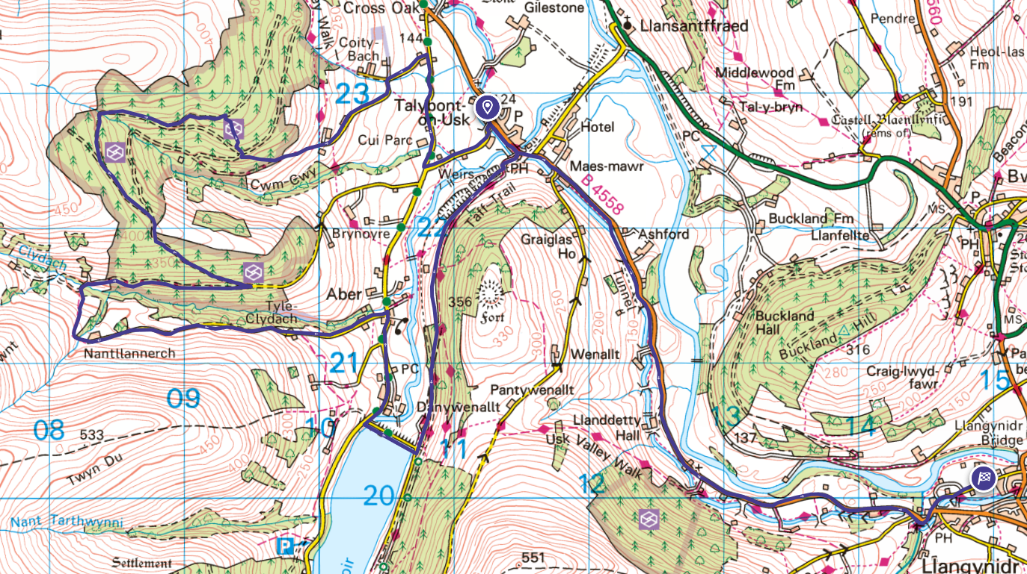
Distance: 20.79km | Start: SO 112 228 End: SO 149 201  What 3 Words location: ///with.leathers.flushes | Height Gain: 403m
(ON CLOCK)

- From the start line at Henderson Hall you will travel left along the main road keeping the canal to your right.

- When you reach The White Hart pub you will turn right up the road and over the steep bridge.

- Here you will join the Taff Trail and follow the bumpy dismantled railway until you reach a fork in the track. Tack the right-hand descending track down toward the reservoir.

- At the reservoir turn right along the road and cross the reservoir.

- At the T-junction go right again and head along the descending road toward Aber.

- Take the second steep road on your left (red phone box on the corner) and start climbing the road until you reach the very top of the road at the house and sheep pen.

- Start following the designated mountain bike route sign posts and cross the small stream, heading right along the track after the stream.

- Follow the steep descent toward a second stream before a short climb again toward Talybont forest.

- Follow the road/track as it undulates for half a mile. Take a hairpin left at a firetrack road which rises up toward the forest.

- Follow the track to the top of the ascent and keep following until a fork in the track. Stay right and start descending until you read another fork. Stay left at this fork.

- Keep following signage, marshals and the designated cycle route at all times.

- Take a right into a single track off-road section which descends toward another fire track road. Follow the marshals at this point toward another single track descent 20metres away.

- The bumpy track now descends towards a road. Follow this road down to a T-juction.

- Take a right at the T-junction and follow the road along toward the first left and follow this road back towards the bridge. Cross the bridge and turn left to your start point.

(OFF CLOCK)

- Once you have crossed the timing mat, the timed section of this stage has finished. You have a short amount of time for refreshments.

- Exit the car park and head left along the main road keeping the canal on your right-hand side at all times.

- Follow the road until you reach the canal bridge at Llangynidr next to the pub. If you are in the pub you’ve gone too far!

- Take a left at this road junction before the bridge and head along the road until you reach a caravan site.

(TRANSISTION)

- Drop off your bike in the field with the bike team and take the track to the left of the field, heading down to the footpath on the riverbank.

Please note – there will be some section of this route which may not be suited to SPD/Clipped shoes as there are some rough sections you may need to get off or cross small streams.

Stage 2 | Mynydd Llangorse hike/run and logic puzzles
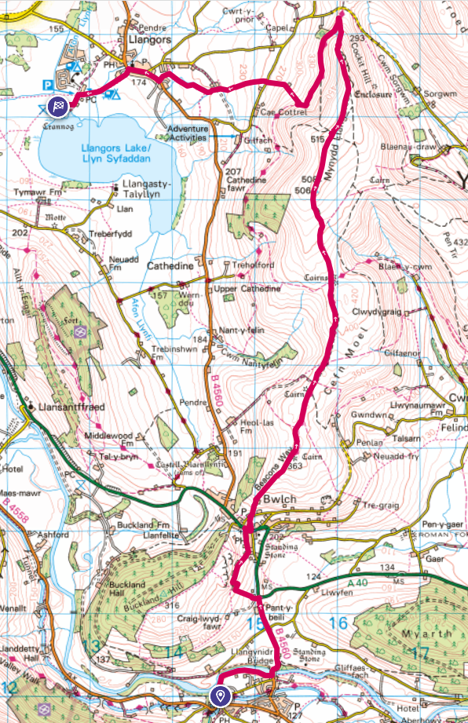
Distance: 14.35km | Start: SO 149 201| ///listings.venturing.regaining  End: SO 126 271  ///forgets.gravest.reinvest | Height Gain: 472m
(ON CLOCK)

- Follow the riverside path toward Llangynidr bridge. Turn left and cross the bridge following the road up along the Beacons Way.

- At the second road junction turn left following the Beacons Way along a road toward the New Inn Pub.

- Cross over the road and follow the Beacons Way path around the church and keep following the path until you reach a forest on your left.

- Keep following the Beacons Way path and keep your eyes out for logic puzzles along your route. You’ll need to provide evidence at the end of the stage that you have attempted each logic puzzle.

- If you fair to pass SO 159 250 by 16:00 your team will have to take a short cut from the hill and receive a time penalty, skipping straight to the canoe stage to finish the day.

- Pass the two cairns torwards the highest point of Mynydd Llangorse before descending on the other side and turning left on the Three Rivers Ride Route.

- Follow the footpaths down to the first road, cross over and keep following the paths past a pond and towards to main road.

- Follow the road to the church before turning left along a footpath leading you back to the lake where you started the day.

Cut off time for return – 16:00

Stage 3 | Team Canoe
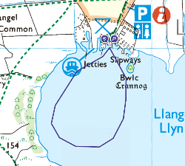

Distance: Approx. 1.5km | Start: NA | Height Gain: N/A
(OFF CLOCK) Time will be allocated to kit up and receive a safety briefing. Teams will then be asked to assemble at the edge of the lake when ready in order to start the next stage.

(ON CLOCK) The team canoe will take a circular course around the lake with your time being manually timed from the edge of the lake.

Day 1 Total 36.6km 875m Height Gain

